Cab Travel Behaviour Trends and Operational Route Insights for Urban Mobility Analysis

ABSTRACT
Urban travel patterns provide important insight into how cab services are used across different locations and time periods within a city. This project focuses on understanding cab travel behavior in urban areas by analyzing how cab services are used across different locations and at different times of the day. The main objective is to identify peak travel hours, frequently visited locations, and the overall movement pattern of trips within the city. By examining these travel trends, it becomes easier to understand which areas experience higher demand and which time periods require greater service attention. This also helps in identifying important routes that contribute most to daily travel activity. The study provides a clear view of how travel demand changes based on location and time, which can support better planning of cab availability and route management. It also helps in improving service efficiency by reducing waiting time and ensuring that travel services are aligned with customer movement patterns. Overall, the analysis offers useful insights into urban mobility and highlights how travel behavior can influence operational planning and service improvement.
2. INTRODUCTION
Urban mobility has become one of the most critical aspects of modern city life, driven by rapid urbanization, population growth, and increasing dependence on on-demand transportation services. In recent years, cab-based transportation systems have emerged as a vital component of urban transit, offering convenience, flexibility, and accessibility to users across diverse geographic locations. With the rise of digital platforms and mobile applications, cab services have evolved into data-rich systems where every trip generates valuable information related to time, location, distance, and user behavior. This abundance of data presents a significant opportunity to analyze and understand travel patterns, which can ultimately lead to improved service efficiency and better decision-making.
The domain of urban transportation is inherently complex, involving multiple dynamic factors such as traffic conditions, user demand, geographic distribution, and time-based variations. Traditional methods of managing transportation systems often rely on static planning and limited observational data, which may not accurately reflect real-world scenarios. As cities continue to expand, these conventional approaches become insufficient to handle the growing demand for efficient and reliable mobility solutions. This has created a need for data-driven approaches that can capture and analyze real-time travel behavior to support intelligent transportation planning.
One of the key challenges in urban mobility is understanding how, when, and where people use cab services. Travel demand is not uniform; it varies significantly based on factors such as time of day, day of the week, purpose of travel, and location. For instance, business-related travel may peak during working hours, while personal or leisure travel may increase during evenings and weekends. Similarly, certain locations within a city may act as high-demand zones due to commercial activity, residential density, or connectivity to other regions. Identifying these patterns is essential for optimizing cab availability, reducing waiting times, and improving overall service quality.
Another important aspect of urban transportation is route efficiency. Frequently used routes often indicate strong connectivity between key locations, and analyzing these routes can help in optimizing travel paths, reducing congestion, and improving fuel efficiency. On the other hand, irregular or less-used routes may highlight areas with limited service coverage or lower demand. Understanding route dynamics enables service providers to allocate resources more effectively and ensure balanced coverage across different regions.
In this context, data analytics plays a crucial role in transforming raw transportation data into meaningful insights. By leveraging analytical tools and techniques, it becomes possible to process large volumes of trip data, identify patterns, and generate actionable information. Technologies such as Python, along with libraries like Pandas, NumPy, and Matplotlib, provide powerful capabilities for data manipulation, statistical analysis, and visualization. These tools enable the extraction of trends related to trip frequency, distance, duration, and purpose, which are essential for understanding user behavior.
The application of data analytics in this project focuses on exploring cab travel behavior through a structured and systematic approach. The dataset used contains detailed information about individual trips, including start and end times, pickup and drop locations, distance travelled, and trip purpose. By preprocessing and analyzing this data, various derived features such as hour, day, month, and route are created to facilitate deeper analysis. These features allow for the identification of temporal patterns, such as peak travel hours and busiest days, as well as spatial patterns, such as frequently used locations and routes.
A significant advantage of using data analytics in urban mobility is the ability to make informed decisions based on empirical evidence rather than assumptions. For example, by identifying peak hours of travel, cab service providers can increase vehicle availability during high-demand periods and reduce idle time during low-demand periods. Similarly, by analyzing popular routes, it becomes possible to optimize routing strategies and improve service efficiency. These insights not only benefit service providers but also enhance the overall user experience by reducing waiting times and ensuring timely availability of transportation.
The importance of this project lies in its ability to bridge the gap between raw data and practical decision-making in the transportation sector. By analyzing cab travel behavior, the study provides a clear understanding of how urban mobility patterns evolve over time and across different locations. This understanding is essential for designing efficient transportation systems that can adapt to changing user needs and environmental conditions.
Furthermore, the project highlights the role of technology in modern transportation systems. With the integration of data analytics, transportation services can move towards smarter and more adaptive models. For instance, predictive analytics can be used to forecast future demand based on historical trends, enabling proactive planning and resource allocation. Similarly, real-time analytics can support dynamic pricing and route optimization, further enhancing operational efficiency.
In real-world applications, the insights derived from this project can be utilized in various ways. Transportation companies can use the findings to improve fleet management, optimize driver schedules, and enhance customer satisfaction. Urban planners can leverage the data to identify high-demand corridors and plan infrastructure development accordingly. Additionally, policymakers can use these insights to design regulations and policies that promote efficient and sustainable transportation systems.
Another important application is in the development of smart city solutions. As cities aim to become more connected and technologically advanced, understanding mobility patterns becomes a key component of urban planning. Data-driven insights can support the integration of different modes of transportation, reduce traffic congestion, and improve environmental sustainability by minimizing unnecessary travel.
In conclusion, the study of cab travel behavior through data analytics provides valuable insights into urban mobility patterns and operational efficiency. By analyzing various aspects of trip data, including time, location, distance, and purpose, this project demonstrates how data can be transformed into meaningful information that supports better decision-making. The integration of analytical tools and techniques not only enhances the understanding of transportation systems but also contributes to the development of smarter, more efficient, and user-centric mobility solutions. This project serves as a foundation for further exploration in the field of data-driven transportation and highlights the growing importance of analytics in shaping the future of urban mobility.
EXISTING SYSTEM
In the current urban transportation environment, cab services primarily operate through a combination of manual record-keeping and basic digital tracking systems. These systems are designed to capture essential trip details such as start time, end time, pickup location, drop location, distance travelled, and purpose of the trip. The dataset provided reflects a typical structure of such an existing system, where each row represents an individual trip recorded with fundamental attributes. While this approach provides a basic level of operational tracking, it lacks advanced analytical capabilities required for deeper insights and optimization.
In real-world scenarios, cab service providers—whether traditional taxi services or app-based aggregators—collect trip data through mobile applications, GPS devices, or driver input systems. When a user books a cab, the system records the start date and time (START_DATE), which marks the beginning of the journey. Similarly, the end date and time (END_DATE) is recorded when the trip is completed. These timestamps are crucial for calculating trip duration and understanding time-based travel patterns. However, in the existing system, this data is often used only for billing purposes rather than analytical exploration.
The category field, which classifies trips as business or personal, is typically included for organizational or reporting needs. For example, corporate users may track business-related travel for reimbursement or auditing purposes. In the given dataset, most trips fall under the business category, indicating that the system is frequently used in a professional context. Despite this classification, the existing system does not deeply analyze how travel behavior differs across categories or how it impacts service demand.
The start and stop columns represent the origin and destination of each trip. These are critical components of the system, as they define the geographical movement of cabs. In practical scenarios, these locations are captured using GPS coordinates and then mapped to human-readable place names. While this information is essential for navigation and fare calculation, the existing system typically does not utilize it for identifying high-demand zones or optimizing route allocation. As a result, opportunities to improve service efficiency through location-based insights are often missed.
The miles column indicates the distance travelled during each trip, which is a key factor in determining fare charges. In current systems, distance is calculated using GPS tracking or predefined route estimates. Although this data is accurate and essential for operational purposes, it is rarely analyzed to distinguish between short-distance and long-distance trips or to identify patterns in travel distance distribution. For instance, trips like the one from Fort Pierce to West Palm Beach covering 63.7 miles represent long-distance travel, but the system does not categorize or utilize this information for strategic planning.
The purpose column provides additional context about why a trip was undertaken, such as meetings, errands, or customer visits. In real-world applications, this information is often manually entered or selected by the user. While it offers valuable insight into user intent, the existing system typically does not perform detailed analysis to understand how different purposes influence travel patterns. For example, business meetings may occur during specific hours, while meal-related trips may be concentrated around lunch or dinner times. Without analytical processing, such patterns remain unexplored.
Operationally, the existing system functions in a transactional manner. Each trip is recorded independently, and the primary focus is on completing the service and processing payments. Data is stored in databases but is not systematically analyzed to extract trends or insights. This results in a reactive system where decisions are made based on immediate requirements rather than long-term patterns. For instance, cab allocation is often based on current demand without considering historical data that could predict future demand more accurately.
Another characteristic of the existing system is the lack of derived features and advanced metrics. Important analytical attributes such as trip duration, peak hours, day-wise trends, and route frequency are not explicitly generated or utilized. This limits the ability of service providers to understand temporal variations in demand or to identify recurring travel patterns. Consequently, the system is unable to support data-driven decision-making or predictive analysis.
Furthermore, the existing system does not effectively handle data inconsistencies or missing values. For example, incomplete entries in the purpose field or ambiguous location names can reduce the quality of analysis. Without proper data preprocessing and validation mechanisms, the reliability of insights derived from such data is compromised. This highlights the need for a more structured and analytical approach to data management.
In terms of scalability, the existing system faces challenges as the volume of data increases. With the growth of urban populations and the expansion of cab services, the amount of trip data generated daily can be substantial. Traditional systems that rely on basic storage and retrieval mechanisms may struggle to process and analyze large datasets efficiently. This further emphasizes the importance of integrating data analytics tools and technologies to enhance system capabilities.
Overall, the existing system serves as a foundational framework for recording and managing cab trip data. It ensures that essential information is captured and stored for operational purposes such as billing and tracking. However, it lacks the analytical depth required to fully leverage the potential of the data. The absence of advanced analytics, predictive capabilities, and data-driven insights limits its effectiveness in addressing the dynamic challenges of urban mobility.
This project aims to overcome these limitations by introducing a data analytics-driven approach that transforms raw trip data into meaningful insights. By building upon the existing system and enhancing it with analytical techniques, it becomes possible to unlock the full potential of the data and support more efficient, intelligent, and user-centric transportation solutions.

DISADVANTAGES OF EXISTING SYSTEM
Although the existing cab travel system provides a basic framework for recording and managing trip-related data, it suffers from several limitations that reduce its effectiveness in addressing modern urban mobility challenges. These disadvantages arise due to the lack of advanced analytics, inefficient data handling, and limited scalability. A detailed explanation of these limitations is provided below.
One of the major drawbacks of the existing system is its lack of data-driven decision-making capabilities. The system primarily functions as a transactional platform that records trip details such as start time, end time, and distance travelled. However, it does not analyze this data to extract meaningful insights. As a result, decisions related to cab allocation, route optimization, and demand forecasting are often based on assumptions or real-time observations rather than historical data patterns. This leads to inefficient resource utilization and missed opportunities for optimization.
Another significant limitation is the inability to identify peak demand periods accurately. While the system records timestamps for each trip, it does not process this information to determine peak travel hours or busiest days. In real-world scenarios, this results in either an oversupply of cabs during low-demand periods or a shortage during high-demand periods. Consequently, customers may experience longer waiting times, and service providers may face reduced operational efficiency.
The existing system also suffers from poor utilization of location data. Although pickup and drop locations are recorded, the system does not analyze these data points to identify high-demand zones or frequently used routes. This lack of spatial analysis prevents service providers from strategically positioning cabs in areas with higher demand. As a result, there is an imbalance in service availability, with some areas experiencing excess supply while others face shortages.
Another drawback is the absence of route optimization and pattern recognition. The system treats each trip as an independent event without considering recurring travel patterns. Frequently used routes, such as those between major business hubs, are not identified or prioritized. This leads to inefficiencies in route planning and increased travel time, which can negatively impact both drivers and passengers.
Data quality issues also pose a significant challenge in the existing system. There is often incomplete or inconsistent data, such as missing values in the purpose field or ambiguous location names like “Unknown Location.” Without proper data validation and preprocessing mechanisms, these inconsistencies reduce the reliability of the dataset. Poor data quality directly affects the accuracy of any analysis and limits the usefulness of the system for decision-making.
The system further lacks feature engineering and derived metrics, which are essential for deeper analysis. Important attributes such as trip duration, peak hour indicators, and weekend flags are not automatically generated. Without these derived features, it becomes difficult to perform detailed analysis or identify trends in travel behavior. This restricts the system to basic reporting rather than advanced analytics.
Another critical limitation is scalability. As the volume of trip data increases with the growth of urban populations and cab usage, the existing system may struggle to handle large datasets efficiently. Traditional data storage and processing methods are not optimized for handling big data, leading to slower performance and delayed insights. This makes it challenging to scale the system to meet the demands of large cities or expanding services.
The existing system is also reactive rather than proactive. It responds to immediate service requests without anticipating future demand. For example, cab allocation is typically based on current availability rather than predicted demand patterns. This reactive approach limits the system’s ability to prepare for peak periods or sudden increases in demand, resulting in inefficiencies and customer dissatisfaction.
Another disadvantage is the lack of integration with advanced technologies such as predictive analytics, machine learning, and real-time data processing. Modern transportation systems increasingly rely on these technologies to improve accuracy and efficiency. However, the existing system does not incorporate such capabilities, which limits its potential for innovation and improvement.
From a user perspective, the system may lead to inconsistent service quality. Due to inefficient cab allocation and lack of demand prediction, customers may face issues such as long waiting times, unavailability of cabs in certain areas, or delays in reaching their destinations. These issues can negatively impact user satisfaction and reduce trust in the service.
Additionally, the system does not provide comprehensive insights into travel behavior. While it records basic trip information, it does not analyze patterns related to trip purpose, distance distribution, or user preferences. This limits the ability of service providers to understand customer needs and tailor services accordingly.
Finally, the existing system lacks decision support mechanisms. There are no dashboards, visualizations, or analytical reports that can help stakeholders interpret the data easily. Without such tools, it becomes difficult for managers and planners to make informed decisions based on the available data.
In conclusion, the existing system is limited by its inability to transform raw data into actionable insights. Its inefficiencies in data utilization, lack of scalability, and absence of advanced analytical capabilities make it unsuitable for addressing the complex and dynamic nature of urban mobility. These limitations highlight the need for a more advanced, data-driven system that can overcome these challenges and provide intelligent solutions for modern transportation needs.
PROPOSED SYSTEM
To overcome the limitations of the existing system, the proposed system introduces a data analytics-driven framework designed to transform raw cab travel data into meaningful insights for better decision-making and operational efficiency. Unlike the traditional approach that focuses only on recording trip details, the proposed system enhances the dataset with additional derived features, structured processing, and analytical capabilities. This enables a deeper understanding of travel behavior, demand patterns, and route efficiency.
The proposed system is built upon an enriched dataset that not only includes basic attributes such as start date, end date, category, start location, stop location, miles, and purpose, but also incorporates derived and analytical columns such as day, month, route, trip duration, hour, weekend indicator, and high-distance classification. These additional features significantly improve the analytical power of the system and allow for multi-dimensional analysis of cab travel patterns.
One of the key improvements in the proposed system is the introduction of feature engineering. Important attributes such as trip_duration are calculated using the difference between start and end timestamps, providing insight into how long each trip takes. Similarly, extracting hour, day, and month from the start date enables time-based analysis, which is essential for identifying peak hours and busiest days. The route column, created by combining start and stop locations, helps in identifying frequently used travel paths, which was not possible in the existing system.
Another major enhancement is the inclusion of logical classification features such as is_weekend and high_distance. The is_weekend column helps distinguish between weekday and weekend travel patterns, allowing for comparative analysis of user behavior. The high_distance column categorizes trips based on mileage thresholds, enabling the identification of long-distance trips that may require different operational strategies. These classifications make the dataset more structured and analysis-ready.
The workflow of the proposed system follows a systematic and structured approach. Initially, raw data is collected from cab trip records, which may include incomplete or unstructured information. The first step in the workflow is data preprocessing, where missing values are handled, inconsistent entries are corrected, and data types are standardized. This ensures that the dataset is clean and reliable for further analysis.
Following preprocessing, the system performs feature extraction and transformation. New columns such as day, month, hour, route, and trip duration are generated from existing data. Logical conditions are applied to create boolean indicators like is_weekend and high_distance. This step transforms the dataset into a more informative and analysis-friendly format.
Once the data is prepared, the system moves to the exploratory data analysis (EDA) phase. In this stage, statistical and visual analysis techniques are applied to uncover patterns and trends. For example, trip frequency is analyzed across different hours to identify peak demand periods. Similarly, location-based analysis is performed to determine high-demand pickup and drop-off points. Route analysis helps in identifying frequently used travel paths, while purpose-based analysis provides insight into user intent.
The proposed system utilizes modern data analytics technologies, primarily based on the Python programming environment. Libraries such as Pandas are used for data manipulation and preprocessing, enabling efficient handling of large datasets. NumPy is used for numerical computations and statistical operations, while Matplotlib is employed for data visualization, allowing trends and patterns to be represented graphically. These tools collectively provide a robust platform for performing end-to-end data analysis.
In addition to analysis, the proposed system emphasizes data-driven decision-making. By identifying peak travel hours, service providers can allocate more cabs during high-demand periods and reduce idle time during low-demand periods. Similarly, by analyzing frequently used routes, the system can support route optimization and better fleet distribution. This leads to improved operational efficiency and enhanced customer satisfaction.
Another important improvement is the system’s ability to handle scalability and large datasets. By using efficient data processing libraries and structured workflows, the proposed system can manage and analyze large volumes of trip data without significant performance issues. This makes it suitable for real-world applications where data is continuously generated.
The proposed system also addresses the issue of data quality and consistency. Through preprocessing and validation techniques, missing values and inconsistencies are minimized, ensuring that the analysis is based on accurate and reliable data. This improves the credibility of insights and supports better decision-making.
Furthermore, the system supports comprehensive analysis across multiple dimensions, including time, location, distance, and purpose. This multi-dimensional approach provides a holistic view of cab travel behavior, enabling stakeholders to understand not just what is happening, but also why it is happening. Such insights are crucial for designing effective transportation strategies.
In real-world scenarios, the proposed system can be applied to improve cab service operations significantly. Transportation companies can use the insights to optimize fleet management, reduce waiting times, and improve route planning. Urban planners can leverage the data to identify high-demand areas and plan infrastructure development accordingly. Additionally, the system can serve as a foundation for advanced applications such as demand prediction and dynamic pricing.
In conclusion, the proposed system represents a significant advancement over the existing system by integrating data analytics, feature engineering, and structured workflows. It transforms raw trip data into actionable insights, enabling efficient and intelligent decision-making. By addressing the limitations of the existing system and leveraging modern technologies, the proposed system provides a scalable, reliable, and effective solution for analyzing urban cab travel behavior and improving overall transportation efficiency.
ADVANTAGES OF PROPOSED SYSTEM
The proposed system introduces a significant transformation in how cab travel data is handled, analyzed, and utilized for decision-making. By integrating data analytics techniques, feature engineering, and structured workflows, the system overcomes the limitations of the existing approach and provides multiple advantages across accuracy, efficiency, automation, scalability, and real-world applicability. These advantages are discussed in detail below.
One of the primary advantages of the proposed system is its high level of accuracy in analysis and insights. Unlike the existing system, which relies on raw and unprocessed data, the proposed system incorporates data preprocessing techniques such as handling missing values, correcting inconsistencies, and standardizing formats. This ensures that the dataset is clean and reliable before analysis. Additionally, the creation of derived features such as trip duration, hour, and route enhances the precision of analysis. For example, accurately calculating trip duration using start and end timestamps allows for better understanding of travel efficiency. Similarly, extracting time-based features helps in identifying exact peak hours, leading to more precise insights.
Another key advantage is improved operational efficiency. The proposed system enables the identification of peak travel hours, high-demand locations, and frequently used routes. With this information, cab service providers can allocate resources more effectively, ensuring that cabs are available where and when they are needed the most. This reduces idle time for drivers and minimizes waiting time for customers. Efficient route analysis also helps in reducing travel time and fuel consumption, contributing to overall cost optimization.
The system also introduces a high degree of automation in data processing and analysis. Tasks that were previously performed manually, such as calculating trip duration or identifying weekend trips, are now automated through feature engineering. For instance, the system automatically extracts day, month, and hour from timestamps and classifies trips based on conditions such as weekend or high distance. This reduces human effort, minimizes errors, and speeds up the overall analysis process. Automation also ensures consistency in results, as the same logic is applied uniformly across the entire dataset.
Scalability is another major advantage of the proposed system. As urban transportation systems generate large volumes of data ежедневно, it is essential to have a system that can handle increasing data sizes efficiently. The use of technologies such as Python, Pandas, and NumPy allows the system to process and analyze large datasets without significant performance degradation. This makes the system suitable for real-world applications where data is continuously generated and needs to be analyzed in a timely manner. The structured workflow ensures that the system can be easily extended to include additional data sources or analytical features in the future.
The proposed system also provides enhanced decision-making capabilities. By transforming raw data into meaningful insights, the system supports data-driven decisions rather than relying on assumptions. For example, understanding which routes are most frequently used can help in optimizing cab distribution, while identifying peak hours can assist in scheduling drivers more effectively. This leads to better planning and improved service quality.
Another important advantage is the system’s ability to deliver real-world benefits in urban mobility management. The insights generated can be used to improve customer satisfaction by reducing waiting times and ensuring timely availability of cabs. Service providers can enhance their operational strategies, leading to increased efficiency and profitability. Urban planners can also benefit from the analysis by identifying high-demand areas and planning infrastructure accordingly.
The system further enables comprehensive behavioral analysis of users. By analyzing trip purpose, distance, and timing, it becomes possible to understand how different users interact with cab services. For instance, business-related trips may dominate during weekdays, while personal trips may increase during weekends. Such insights can help in designing targeted services and improving user experience.
Another advantage is the flexibility and adaptability of the system. The modular design allows for easy updates and modifications. New features, analytical models, or visualization techniques can be added without disrupting the existing system. This ensures that the system remains relevant and can adapt to changing requirements and technological advancements.
The proposed system also improves data visualization and interpretability. By using tools like Matplotlib, the system can present data in graphical formats such as charts and plots. These visualizations make it easier for stakeholders to understand complex patterns and trends, facilitating better communication and decision-making.
Finally, the system lays the foundation for future advancements such as predictive analytics and machine learning integration. With a well-structured and enriched dataset, it becomes possible to develop models that can predict future demand, estimate travel time, or optimize pricing strategies. This opens up new possibilities for innovation and continuous improvement in transportation systems.
In conclusion, the proposed system offers a comprehensive set of advantages that significantly enhance the analysis and management of cab travel data. By improving accuracy, increasing efficiency, enabling automation, supporting scalability, and delivering real-world benefits, the system provides a robust and future-ready solution for urban mobility analysis. It not only addresses the shortcomings of the existing system but also sets a strong foundation for advanced data-driven applications in the transportation domain.
INTRODUCTION TO APPLICATION
The application developed in this project is a data analytics-based cab travel analysis system designed to study urban mobility patterns and extract meaningful insights from cab trip data. The primary purpose of this application is to transform raw trip-level data into structured, analyzable information that can be used to understand travel behavior, identify demand patterns, and improve operational efficiency in cab services.
At its core, the system processes historical cab trip data containing attributes such as trip start and end time, pickup and drop locations, distance travelled, and trip purpose. Through a series of preprocessing and analytical steps, the application enhances this raw data by generating additional features such as trip duration, travel hour, day of the week, route, and classification indicators like weekend trips and high-distance journeys. These enhancements allow the system to perform detailed analysis across multiple dimensions including time, location, and user behavior.
The application is designed to perform several key functions. It analyzes temporal patterns to identify peak travel hours and busiest days, helping in understanding when demand is highest. It performs location-based analysis to determine frequently used pickup and drop-off points, which are critical for optimizing cab availability. Additionally, it conducts route analysis to identify commonly used travel paths, enabling better route planning and resource allocation. The system also examines trip purpose and category, providing insights into why users utilize cab services and how behavior varies across different use cases.
One of the key features of the application is its feature engineering capability, where new informative columns are derived from existing data. For example, the system automatically calculates trip duration from timestamps, extracts hour and day information, and constructs route identifiers by combining start and stop locations. It also includes logical classification features such as identifying whether a trip occurred on a weekend or whether it qualifies as a high-distance trip. These features significantly enhance the analytical depth of the application.
Another important feature is the data preprocessing module, which ensures that the dataset is clean and consistent before analysis. This includes handling missing values, correcting inconsistencies, and standardizing formats. By improving data quality, the application ensures that the insights generated are accurate and reliable.
The application also provides data visualization capabilities, enabling users to interpret analysis results through graphical representations such as bar charts and distributions. These visualizations help in clearly identifying trends, patterns, and anomalies in the data, making it easier for users to understand complex information.
From a user interaction perspective, the application is designed to be simple and efficient. The user typically interacts with the system through a Jupyter Notebook environment, where they can load the dataset, execute analysis scripts, and view results in both tabular and graphical formats. Users can modify parameters, explore different aspects of the data, and generate customized insights based on their requirements. This interactive approach allows users to gain a deeper understanding of the dataset and experiment with different analytical techniques.
The data flow within the system follows a structured pipeline. Initially, raw data is loaded into the system from a dataset file. The first stage involves data preprocessing, where the data is cleaned and prepared for analysis. In the next stage, feature engineering is performed to create additional columns such as trip duration, hour, day, and route. Once the dataset is enriched, it moves to the analysis stage, where various statistical and exploratory techniques are applied to identify patterns and trends.
Following analysis, the system generates insights and visualizations, which are presented to the user for interpretation. These outputs may include summaries such as top locations, most frequent routes, trip distributions by hour or day, and purpose-based analysis. The final stage involves drawing conclusions from the analysis and using these insights to support decision-making.
Technologically, the application is built using the Python programming language and leverages powerful libraries such as Pandas for data manipulation, NumPy for numerical operations, and Matplotlib for visualization. These tools enable efficient handling of large datasets and support advanced analytical operations.
In real-world scenarios, this application can be used by cab service providers, data analysts, and urban planners to gain insights into travel behavior and optimize transportation systems. By understanding when and where demand is highest, service providers can improve cab availability and reduce waiting times. Similarly, route analysis can help in optimizing travel paths and improving fuel efficiency.
In conclusion, the application developed in this project serves as a comprehensive data analytics solution for studying cab travel behavior. It integrates data preprocessing, feature engineering, analysis, and visualization into a unified system that transforms raw data into actionable insights. By providing a clear understanding of urban mobility patterns, the application supports better planning, improved efficiency, and enhanced service quality in the transportation domain.

BLOCK DIAGRAM
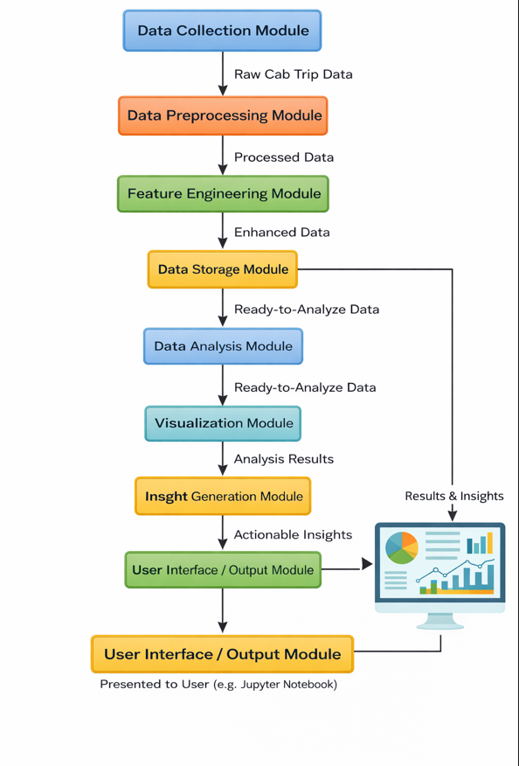
The block diagram of the proposed system represents the overall architecture and workflow of the cab travel analysis application. It illustrates how raw data is processed through multiple stages to generate meaningful insights. Each component in the block diagram plays a specific role in transforming unstructured trip data into structured analytical outputs. The system follows a sequential data flow, ensuring that each stage builds upon the previous one.
1. Data Collection Module
The first component of the system is the Data Collection Module, which is responsible for gathering raw cab trip data. This data typically includes attributes such as start date, end date, category, pickup location, drop location, distance travelled, and trip purpose. In real-world scenarios, this data may be collected from cab service applications, GPS tracking systems, or company databases. The collected data serves as the foundation for the entire analysis process.
2. Data Preprocessing Module
Once the data is collected, it is passed to the Data Preprocessing Module. This component plays a crucial role in preparing the data for analysis. It involves several steps such as handling missing values, correcting inconsistent entries, removing duplicates, and standardizing data formats. For example, missing values in the purpose column may be filled or labeled appropriately, and date formats are converted into a consistent structure. This step ensures that the dataset is clean, reliable, and suitable for further processing.
3. Feature Engineering Module
After preprocessing, the data moves to the Feature Engineering Module, where new attributes are created from existing data. This is a key component of the proposed system, as it enhances the dataset with additional information. Derived features include:
- Trip Duration calculated from start and end timestamps
- Hour, Day, and Month extracted from the start date
- Route created by combining start and stop locations
- Weekend Indicator (is_weekend) to classify trips as weekday or weekend
- High Distance Indicator (high_distance) to identify long-distance trips
These features provide deeper insights and enable multi-dimensional analysis.
4. Data Storage Module
The processed and enriched data is then stored in the Data Storage Module. This component ensures that the dataset is organized and easily accessible for analysis. In practical implementations, this may involve storing data in structured formats such as CSV files, databases, or data frames within a programming environment like Python. Efficient storage is important for handling large datasets and ensuring smooth data retrieval.
5. Data Analysis Module
The next stage is the Data Analysis Module, where the core analytical operations are performed. In this module, the system applies statistical and exploratory techniques to identify patterns and trends. Examples of analysis include:
- Identifying peak travel hours using the hour column
- Analyzing trip distribution across days and months
- Determining frequently used pickup and drop locations
- Identifying popular routes using the route column
- Examining trip purposes and categories
This module transforms processed data into meaningful insights.
6. Visualization Module
Following analysis, the results are passed to the Visualization Module. This component converts analytical findings into graphical representations such as bar charts, line graphs, and distribution plots. Visualization makes it easier to interpret complex data and communicate insights effectively. For instance, graphs showing trips by hour or top locations provide a clear understanding of demand patterns.
7. Insight Generation Module
The Insight Generation Module interprets the analyzed and visualized data to derive actionable conclusions. This includes identifying peak demand periods, high-traffic routes, and user behavior patterns. The insights generated in this stage are critical for decision-making and operational improvements.
8. User Interface / Output Module
The final component is the User Interface or Output Module, where results are presented to the user. In this project, the interface is implemented using a Jupyter Notebook, where users can view tables, charts, and summarized insights. Users can interact with the system by running analysis scripts, modifying parameters, and exploring different aspects of the data.

DATA FLOW IN THE SYSTEM (STEP-BY-STEP)
The data flow in the system follows a logical sequence:
- Data Input: Raw cab trip data is collected from source files or databases.
- Preprocessing: The data is cleaned and standardized to remove errors and inconsistencies.
- Feature Engineering: New analytical columns are generated to enrich the dataset.
- Storage: The processed data is stored in a structured format for easy access.
- Analysis: Statistical and exploratory analysis is performed to identify patterns.
- Visualization: Analytical results are converted into graphical formats.
- Insight Generation: Key findings and patterns are extracted from the analysis.
- Output Presentation: Results are displayed to the user through tables and charts.

SUMMARY
The block diagram of the proposed system represents a well-structured and efficient workflow for analyzing cab travel data. Each component plays a vital role in ensuring that raw data is transformed into meaningful insights. The step-by-step data flow ensures accuracy, consistency, and clarity in the analysis process. By integrating preprocessing, feature engineering, analysis, and visualization, the system provides a comprehensive solution for understanding urban mobility patterns and improving transportation efficiency.
9. DATA ANALYTICS SECTION
9.1 OVERVIEW
Data analytics is the process of examining raw data to extract meaningful insights, identify patterns, and support decision-making. It involves collecting, cleaning, transforming, and analyzing data using statistical and computational techniques. In modern applications, data analytics plays a crucial role in converting large volumes of unstructured data into valuable information that can be used to improve performance, efficiency, and strategic planning.
In the context of this project, data analytics is used to study cab travel behavior and urban mobility patterns. The dataset consists of detailed trip-level information such as timestamps, locations, distance, and purpose of travel. By applying data analytics techniques, this raw data is transformed into structured insights that help in understanding how cab services are used across different times and locations. This enables the identification of peak travel hours, frequently used routes, and high-demand areas, which are essential for optimizing cab operations.
The importance of data analytics in this project lies in its ability to provide data-driven insights rather than relying on assumptions or manual observations. Without analytics, the dataset would remain a collection of records with limited practical value. However, through systematic analysis, it becomes possible to uncover hidden trends such as which hours experience the highest demand, which locations serve as major travel hubs, and how travel behavior varies across weekdays and weekends. These insights are critical for improving service efficiency and enhancing user experience.
Data analytics in this project also helps in improving decision-making and operational planning. For example, by analyzing trip frequency across different hours, service providers can allocate more cabs during peak times and reduce availability during low-demand periods. Similarly, by identifying frequently used routes, the system can support better route planning and reduce travel time. This leads to more efficient use of resources and improved service quality.
Another important role of data analytics is in understanding user behavior. By analyzing attributes such as trip purpose and category, it becomes possible to identify why users are traveling and how their needs vary. For instance, business-related trips may dominate during working hours, while personal trips may increase during weekends. Such insights can help in designing targeted services and improving customer satisfaction.
Data analytics can be broadly categorized into four main types, each playing a specific role in this project:
1. Descriptive Analytics
Descriptive analytics focuses on summarizing historical data to understand what has happened. In this project, descriptive analytics is used extensively to analyze past cab trips. Examples include identifying the number of trips per day, most frequent locations, and distribution of trips across hours. It provides a clear overview of travel patterns and forms the foundation for further analysis.
2. Diagnostic Analytics
Diagnostic analytics aims to understand why certain patterns or trends occur. In this project, it helps explain reasons behind observed behaviors. For example, if a particular route has a high number of trips, diagnostic analysis can help determine whether it is due to business activity, location connectivity, or population density. This type of analysis adds depth to the insights generated.
3. Predictive Analytics
Predictive analytics uses historical data to forecast future trends. Although this project primarily focuses on exploratory analysis, the structured dataset and insights generated can be used as a foundation for predictive modeling. For instance, future demand for cabs during specific hours or days can be estimated based on past trends. This helps in proactive planning and resource allocation.
4. Prescriptive Analytics
Prescriptive analytics provides recommendations based on data insights. In this project, it can suggest actions such as increasing cab availability during peak hours, optimizing frequently used routes, or improving service in high-demand areas. This type of analytics directly supports decision-making and operational improvements.
The integration of these types of analytics enables a comprehensive understanding of cab travel behavior. While descriptive analytics provides a summary of past data, diagnostic analytics explains the reasons behind patterns, predictive analytics forecasts future trends, and prescriptive analytics recommends actionable solutions.
Technologically, the project utilizes tools such as Python along with libraries like Pandas, NumPy, and Matplotlib to perform data analytics. Pandas is used for data manipulation and preprocessing, NumPy supports numerical computations, and Matplotlib is used for visualization. These tools enable efficient handling of large datasets and provide powerful capabilities for analysis.
In summary, data analytics serves as the backbone of this project, enabling the transformation of raw cab travel data into meaningful insights. It plays a vital role in understanding urban mobility patterns, improving operational efficiency, and supporting data-driven decision-making. By leveraging different types of analytics, the project not only explains past travel behavior but also provides a foundation for future improvements in transportation systems.
9.2 DATA DESCRIPTION
The dataset used in this project represents detailed records of cab travel activities and serves as the foundation for analyzing urban mobility patterns. Each record in the dataset corresponds to a single cab trip and contains multiple attributes that capture temporal, spatial, and behavioral aspects of travel. The dataset is structured in a tabular format, making it suitable for data analysis using tools such as Python, Pandas, and NumPy.
The primary objective of using this dataset is to understand how cab services are utilized across different locations, time periods, and purposes. By analyzing this data, it becomes possible to identify patterns such as peak travel hours, frequently used routes, and high-demand locations. The dataset includes both raw and derived columns, which together provide a comprehensive view of travel behavior.
STRUCTURE OF THE DATASET
The dataset consists of multiple columns, each representing a specific attribute of a cab trip. These columns can be broadly categorized into three types:
- Temporal Data (Time-based attributes)
- Spatial Data (Location-based attributes)
- Analytical/Derived Data (Generated features for analysis)

COLUMN-WISE DESCRIPTION
1. start_date (Temporal Data – DateTime)
This column represents the exact date and time when a trip begins. It is one of the most important fields in the dataset as it forms the basis for time-based analysis. From this column, additional features such as hour, day, and month are extracted. It helps in identifying peak travel hours and daily or monthly patterns.
2. end_date (Temporal Data – DateTime)
This column indicates the exact date and time when a trip ends. It is used along with the start_date column to calculate the total duration of each trip. This helps in analyzing travel efficiency and time taken for different routes.
3. category (Categorical Data)
The category column classifies each trip as either business or personal. This helps in understanding how travel behavior differs based on the nature of the trip. For example, business trips may follow a structured schedule, while personal trips may vary more widely.
4. start (Spatial Data – Categorical)
This column represents the pickup location of the trip. It is a key spatial attribute that helps in identifying high-demand origin points. By analyzing this column, it becomes possible to determine which locations generate the most cab requests.
5. stop (Spatial Data – Categorical)
The stop column indicates the destination of the trip. Similar to the start column, it helps in identifying frequently visited locations and understanding movement patterns across different areas.
6. miles (Numerical Data – Continuous)
This column shows the distance travelled during each trip, measured in miles. It is an important metric for analyzing trip length and categorizing trips into short-distance and long-distance journeys. It also plays a role in identifying high-distance trips.
7. purpose (Categorical Data)
The purpose column describes the reason for the trip, such as meeting, customer visit, errand, or meal-related activity. This provides insight into user intent and helps in understanding why cab services are being used.

DERIVED / ANALYTICAL COLUMNS
The proposed system enhances the dataset by generating additional columns that improve analytical capabilities.
8. day (Categorical Data)
This column represents the day of the week on which the trip occurred. It is derived from the start_date column and is used for analyzing travel patterns across different days.
9. month (Categorical Data)
This column indicates the month in which the trip took place. It is useful for identifying seasonal trends or monthly variations in travel demand.
10. route (Categorical Data)
The route column is created by combining the start and stop locations. It represents the complete travel path of each trip. This is useful for identifying frequently used routes and analyzing connectivity between locations.
11. trip_duration (Numerical Data – Continuous)
This column represents the total duration of the trip in minutes. It is calculated using the difference between end_date and start_date. It helps in analyzing travel time and efficiency.
12. hour (Numerical Data – Discrete)
The hour column is extracted from the start_date and indicates the hour at which the trip began. It is used to identify peak travel hours and analyze time-based demand patterns.
13. is_weekend (Boolean Data)
This column indicates whether a trip occurred on a weekend. It stores TRUE for Saturday and Sunday, and FALSE for weekdays. It helps in comparing travel behavior between weekdays and weekends.
14. high_distance (Boolean Data)
This column classifies trips based on distance. Trips exceeding a certain threshold (for example, 20 miles) are marked as TRUE, while others are marked as FALSE. This helps in identifying long-distance travel patterns.

RELEVANCE OF THE DATASET
The dataset is highly relevant for analyzing urban cab travel behavior because it captures multiple dimensions of travel:
- Time Dimension: Enables analysis of when trips occur (hour, day, month)
- Location Dimension: Helps identify where trips originate and end
- Distance Dimension: Provides insight into how far users travel
- Behavioral Dimension: Explains why users travel (purpose, category)
By combining these dimensions, the dataset allows for a comprehensive understanding of cab usage patterns. It supports various types of analysis such as trend analysis, route optimization, demand forecasting, and behavioral analysis.
Furthermore, the inclusion of derived features significantly enhances the analytical power of the dataset. These features enable more detailed and accurate insights, making the dataset suitable for both exploratory analysis and advanced modeling.
SUMMARY
In summary, the dataset used in this project is a well-structured and enriched collection of cab trip records that provides a complete view of urban mobility patterns. It includes a combination of temporal, spatial, numerical, and categorical data, along with derived features that enhance analytical capabilities. This dataset forms the backbone of the project and plays a crucial role in generating meaningful insights for improving cab service efficiency and decision-making.
9.3 DATA PREPROCESSING
Data preprocessing is a critical step in the data analytics pipeline, as it transforms raw and unstructured data into a clean, consistent, and analysis-ready format. In this project, preprocessing plays a vital role in ensuring that the cab travel dataset is accurate, reliable, and suitable for extracting meaningful insights. Since real-world data often contains inconsistencies, missing values, and formatting issues, a structured preprocessing approach is necessary before performing any analysis.
The preprocessing phase in this project involves four major steps: data cleaning, handling missing values, data formatting, and feature engineering. Each of these steps contributes to improving the quality and usability of the dataset.

1. DATA CLEANING
Data cleaning is the process of identifying and correcting errors or inconsistencies in the dataset. In the context of the cab travel dataset, this involves checking for duplicate records, incorrect entries, and inconsistent values.
Duplicate entries can occur when the same trip is recorded multiple times. These duplicates are removed to avoid skewing the analysis results. Additionally, inconsistent location names, such as variations in spelling or formatting (e.g., "Karachi" vs "Kar?chi"), are standardized to ensure uniformity.
Another aspect of cleaning involves verifying numerical values such as miles and trip duration. Any unrealistic or extreme values are carefully examined to determine whether they are valid or require correction. This step ensures that the dataset accurately reflects real-world travel behavior.

2. HANDLING MISSING VALUES
Missing values are a common issue in real-world datasets and can significantly impact the quality of analysis if not handled properly. In this project, missing values may appear in columns such as purpose or location.
Different strategies are used to handle missing values depending on the nature of the data:
- For categorical fields like purpose, missing values may be replaced with a placeholder such as "Unknown" to maintain consistency.
- For location fields, missing entries are either labeled appropriately or analyzed separately to avoid misleading results.
- If missing values are minimal and do not significantly affect the dataset, those records may be removed.
Handling missing values ensures that the dataset remains complete and does not introduce bias or errors in the analysis.

3. DATA FORMATTING
Data formatting involves converting data into a consistent and standardized structure that can be easily processed and analyzed. In this project, several formatting steps are performed:
- Date and Time Conversion: The start_date and end_date columns are converted into a proper datetime format. This allows for accurate calculation of trip duration and extraction of time-based features.
- Standardizing Text Fields: Columns such as start, stop, and purpose are standardized to ensure consistent naming conventions.
- Data Type Conversion: Numerical columns such as miles and trip_duration are converted into appropriate numeric data types, while categorical columns are properly labeled.
Proper formatting is essential for ensuring that analytical operations are performed correctly and efficiently.

4. FEATURE ENGINEERING
Feature engineering is one of the most important steps in preprocessing, as it enhances the dataset by creating new attributes that provide additional insights. In this project, several new features are derived from existing data:
- Trip Duration: Calculated as the difference between end_date and start_date, representing the total time taken for each trip.
- Hour: Extracted from start_date to analyze time-based patterns and identify peak travel hours.
- Day: Derived from start_date to study day-wise travel trends.
- Month: Extracted to analyze monthly variations in travel behavior.
- Route: Created by combining start and stop locations, representing the complete travel path.
- is_weekend: A boolean feature that indicates whether the trip occurred on a weekend.
- high_distance: A classification feature that identifies trips exceeding a certain mileage threshold.
These engineered features significantly improve the analytical capabilities of the dataset by enabling multi-dimensional analysis across time, location, and behavior.

IMPORTANCE OF DATA PREPROCESSING
Data preprocessing ensures that the dataset is accurate, consistent, and ready for analysis. Without proper preprocessing, the results of the analysis may be misleading or incorrect. By cleaning the data, handling missing values, standardizing formats, and creating new features, the system is able to extract meaningful insights with higher reliability.

SUMMARY
In summary, data preprocessing is a foundational step in this project that prepares raw cab travel data for effective analysis. Through systematic cleaning, handling of missing values, proper formatting, and feature engineering, the dataset is transformed into a structured and enriched format. This enables accurate analysis, better visualization, and reliable insight generation, ultimately supporting improved decision-making in urban mobility systems.
9.4 EXPLORATORY DATA ANALYSIS (EDA)
Exploratory Data Analysis (EDA) is a crucial phase in the data analytics process that focuses on understanding the structure, patterns, and relationships within the dataset. In this project, EDA is performed on the cab travel dataset to uncover meaningful insights related to travel behavior, demand patterns, and operational trends. By analyzing the data using statistical summaries and visualizations, it becomes possible to identify key patterns that influence urban mobility.
The EDA process in this project examines the dataset across multiple dimensions, including time, location, distance, and purpose of travel. Each of these dimensions provides unique insights into how cab services are utilized.

1. TEMPORAL ANALYSIS (TIME-BASED PATTERNS)
One of the most significant aspects of EDA in this project is the analysis of time-based patterns. By examining the hour column, it is observed that cab usage varies significantly throughout the day. The number of trips increases gradually from morning hours and reaches its peak during the afternoon and early evening, particularly between 1 PM and 6 PM. This trend indicates that these hours represent peak demand periods, likely driven by business activities and daily commuting patterns.
In contrast, late-night and early-morning hours show minimal activity, suggesting lower demand during these periods. This uneven distribution highlights the importance of aligning cab availability with peak hours to ensure efficient service.
Further analysis of the day column reveals that travel demand is relatively consistent across weekdays, with slight variations. Friday records the highest number of trips, indicating increased activity towards the end of the workweek. Weekend days such as Saturday and Sunday also show notable activity, reflecting personal and leisure travel. This suggests that cab services are used for both professional and personal purposes, depending on the day.

2. LOCATION-BASED ANALYSIS (SPATIAL PATTERNS)
The analysis of start and stop locations provides valuable insights into geographic travel patterns. Certain locations, such as Cary and Morrisville, appear frequently as both pickup and drop-off points, indicating that they are major hubs of travel activity. This suggests that these areas have high demand and require consistent cab availability.
Additionally, the presence of repeated routes between specific locations highlights strong connectivity between key regions. For example, frequent trips between Cary and Morrisville indicate a high level of interaction between these areas, possibly due to business or residential connections.
However, the dataset also contains entries labeled as "Unknown Location," which indicates missing or incomplete data. This highlights a data quality issue that needs to be addressed during preprocessing to ensure accurate analysis.

3. ROUTE ANALYSIS
The route column, created by combining start and stop locations, provides a deeper understanding of travel patterns. EDA reveals that certain routes are used repeatedly, indicating consistent demand along these paths. Routes such as Morrisville to Cary and Cary to Morrisville are among the most frequent, suggesting strong bidirectional travel.
Interestingly, routes where the start and stop locations are the same (e.g., Cary to Cary) also appear frequently. This may represent short-distance travel within the same area, indicating local movement patterns.
Route analysis is particularly useful for identifying high-demand corridors and optimizing cab allocation. By focusing on frequently used routes, service providers can improve efficiency and reduce travel time.

4. DISTANCE ANALYSIS
The miles column is analyzed to understand the distribution of trip distances. The majority of trips fall within a short-distance range, indicating that most cab rides are used for nearby travel. However, there are also instances of long-distance trips, such as those exceeding 60 miles, which represent a different category of travel.
The average distance of trips provides a general idea of typical travel behavior, while the presence of extreme values (e.g., very long trips) highlights outliers in the dataset. These outliers may represent special cases such as inter-city travel or data entry anomalies.
The high_distance feature further helps in categorizing trips, allowing for a clearer distinction between short and long journeys. This classification is useful for analyzing how travel behavior varies based on distance.

5. PURPOSE-BASED ANALYSIS
The purpose column provides insight into why users are utilizing cab services. EDA shows that the majority of trips are associated with meetings, followed by meal/entertainment and errands. This indicates that cab services are predominantly used for business-related activities.
The relatively lower frequency of categories such as airport travel or charity trips suggests that these are less common use cases. Understanding trip purpose helps in identifying user needs and tailoring services accordingly.

6. CATEGORY ANALYSIS
The analysis of the category column reveals that business trips dominate the dataset, with a significantly smaller proportion of personal trips. This suggests that cab services are heavily utilized in professional contexts, particularly during working hours.
This distribution aligns with the observed temporal patterns, where peak hours correspond to typical business activity periods. It also reinforces the importance of focusing on business hubs and working hours for optimizing service delivery.

7. DISTRIBUTION AND PATTERN INSIGHTS
Overall, the dataset exhibits clear patterns and distributions across multiple dimensions:
- Time Distribution: Peak during afternoon and evening hours
- Location Distribution: Concentrated around key hubs like Cary and Morrisville
- Route Distribution: Frequent repetition of specific routes
- Distance Distribution: Majority short-distance with some long-distance outliers
- Purpose Distribution: Dominated by business-related activities
These patterns highlight the structured nature of urban mobility and demonstrate how travel behavior is influenced by time, location, and purpose.

IMPORTANCE OF EDA IN THIS PROJECT
EDA plays a vital role in this project by providing a clear understanding of the dataset before applying advanced analysis. It helps in identifying trends, detecting anomalies, and forming hypotheses about travel behavior. Without EDA, it would be difficult to interpret the data accurately or draw meaningful conclusions.

SUMMARY
In summary, exploratory data analysis provides a comprehensive view of cab travel behavior by examining patterns, trends, and distributions within the dataset. By analyzing temporal, spatial, and behavioral dimensions, the project uncovers key insights into how cab services are used. These insights form the foundation for further analysis and support data-driven decision-making in urban mobility systems.
9.5 TOOLS USED
The successful implementation of this project relies on a combination of powerful data analytics tools and technologies. These tools are used for data preprocessing, analysis, visualization, and reporting. The primary tools used in this project include Jupyter Notebook with Python libraries such as Pandas, NumPy, and Matplotlib, along with SQL (MySQL) for querying and Microsoft Power BI for visualization and dashboard creation. Each tool plays a specific role in transforming raw data into meaningful insights.
Jupyter Notebook serves as the main development environment for this project. It provides an interactive platform where code, outputs, and visualizations can be executed and displayed in a single interface. This makes it easier to perform step-by-step analysis, debug code, and document findings. The notebook environment is particularly useful for exploratory data analysis, as it allows users to experiment with different approaches and immediately observe results.
Pandas is one of the most important libraries used in this project for data manipulation and preprocessing. It provides data structures such as DataFrames that allow efficient handling of tabular data. In this project, Pandas is used to load the dataset, clean the data, handle missing values, and perform transformations. For example, the dataset is imported using functions like read_csv(), and columns such as start_date and end_date are converted into datetime format. Pandas is also used to create new columns such as trip_duration, hour, and route. Additionally, grouping and aggregation operations such as identifying top locations or counting trips by day are performed using functions like groupby() and value_counts().
NumPy is used for numerical computations and supports efficient mathematical operations on large datasets. It is particularly useful for performing calculations such as determining thresholds for high-distance trips or handling numerical transformations. In this project, NumPy functions are used to apply logical conditions, such as identifying trips where distance exceeds a certain value. It also helps in optimizing performance when working with large datasets by enabling vectorized operations.
Matplotlib is used for data visualization, allowing the representation of data in graphical form. Visualization is an essential part of this project, as it helps in understanding patterns and trends more clearly. Matplotlib is used to create bar charts, line graphs, and distribution plots. For instance, graphs showing trips by hour help identify peak travel times, while charts of top locations highlight high-demand areas. These visualizations make it easier to communicate insights and support decision-making.
In addition to Python-based tools, SQL using MySQL is used for querying and managing structured data. SQL plays an important role in filtering, aggregating, and retrieving specific subsets of data from databases. For example, queries can be written to extract top routes, calculate average trip distances, or filter trips based on category or purpose. SQL operations such as SELECT, WHERE, GROUP BY, and ORDER BY are commonly used in this project. For instance, a query can be used to find the most frequent start locations by grouping data based on the start column and counting occurrences. SQL provides an efficient way to handle large datasets and perform operations directly within the database.
Microsoft Power BI is used for creating interactive dashboards and visual reports. It allows users to connect to the dataset, transform data, and build visualizations such as charts, graphs, and KPI indicators. In this project, Power BI is used to present insights in a user-friendly and interactive manner. For example, dashboards can display metrics such as total trips, average distance, and peak hours. Filters and slicers can be applied to analyze data based on specific conditions such as month or category. Power BI enhances the presentation of results and makes it easier for stakeholders to interpret the data.
A practical example of tool integration in this project can be seen in the workflow. Initially, the dataset is loaded and cleaned using Pandas in Jupyter Notebook. Feature engineering is performed to create new columns such as trip duration and route. NumPy is used for numerical operations and logical conditions. Matplotlib is then used to visualize trends such as trip distribution by hour. SQL queries are applied to extract specific insights from the dataset, such as identifying the most frequent routes. Finally, Power BI is used to create dashboards that present these insights in an interactive format.
In conclusion, the combination of Jupyter Notebook, Pandas, NumPy, Matplotlib, SQL, and Power BI provides a comprehensive toolkit for data analysis in this project. Each tool contributes to a different stage of the workflow, from data preprocessing to visualization and reporting. Together, they enable efficient analysis, accurate insights, and effective presentation of results, making them essential for understanding cab travel behavior and improving urban mobility systems.
10. SOFTWARE REQUIREMENTS
Software requirements define the essential tools and technologies needed to develop, execute, and analyze the project effectively. In this project, various software components are used to perform data preprocessing, analysis, and visualization. These tools provide the necessary environment and capabilities to handle large datasets and generate meaningful insights.
Jupyter Notebook is used as the primary development environment for this project. It is an interactive web-based application that allows users to write and execute code, visualize outputs, and document the analysis in a single interface. It supports step-by-step execution, which is highly useful for data analysis tasks. The notebook format enables better understanding and presentation of results, making it ideal for academic and analytical projects.
Python is the core programming language used in this project. It is widely used in data analytics due to its simplicity, readability, and extensive library support. Python provides a flexible environment for performing data manipulation, analysis, and visualization. Its ability to integrate with various libraries and tools makes it a powerful choice for handling complex data-driven tasks.
Pandas is a Python library specifically designed for data manipulation and analysis. It provides efficient data structures such as DataFrames, which allow easy handling of structured data. In this project, Pandas is essential for loading datasets, cleaning data, handling missing values, and performing transformations. It simplifies operations such as filtering, grouping, and aggregating data, making it a fundamental tool for data analysis.
NumPy is another important Python library used for numerical computations. It provides support for multi-dimensional arrays and efficient mathematical operations. NumPy enhances the performance of data processing by enabling fast computations on large datasets. It is particularly useful for performing calculations, applying conditions, and supporting analytical operations within the project.
Matplotlib is a data visualization library used to represent data graphically. It allows the creation of various types of charts such as bar graphs, line plots, and histograms. Visualization plays a crucial role in this project, as it helps in understanding patterns and trends in the dataset. Matplotlib provides the necessary tools to present analytical results in a clear and visually appealing manner.
All these software components work together to create a complete data analytics environment. Jupyter Notebook provides the platform for execution, Python acts as the programming backbone, and libraries like Pandas, NumPy, and Matplotlib enable data processing and visualization. These tools are lightweight, widely available, and suitable for academic as well as real-world applications.
In conclusion, the software requirements for this project are carefully chosen to support efficient data analysis and visualization. They provide a robust and flexible environment that enables the successful implementation of the project and ensures accurate and meaningful results.
11. HARDWARE REQUIREMENTS
The hardware requirements for this project are minimal and can be fulfilled using a standard personal computer or laptop. Since the project involves data analysis using Python and related tools, moderate system specifications are sufficient for smooth execution.
Processor
- Minimum: Intel Core i3 or equivalent
- Recommended: Intel Core i5 or higher
- Role:
  - Handles data processing and computations
  - Ensures faster execution of analysis tasks
RAM (Random Access Memory)
- Minimum: 4 GB
- Recommended: 8 GB or higher
- Role:
  - Supports smooth execution of Jupyter Notebook
  - Handles large datasets efficiently
  - Prevents system lag or crashes during processing
Storage
- Minimum: 256 GB
- Recommended: 512 GB or higher (SSD preferred)
- Role:
  - Stores datasets, code files, and outputs
  - SSD improves speed of data access and application loading
  - Ensures better performance compared to HDD
Operating System (OS)
- Supported Systems:
  - Windows (10 or later)
  - Linux
  - macOS
- Role:
  - Provides environment to run Python and tools
  - Ensures compatibility with libraries like Pandas, NumPy, Matplotlib
Additional Requirements
- Stable internet connection (for installing libraries and updates)
- Basic input/output devices (keyboard, mouse, display)
Summary
- Moderate hardware is sufficient for this project
- No high-end system is required
- Suitable for students and academic environments
HARDWARE SUFFICIENCY JUSTIFICATION
The hardware configuration specified for this project is sufficient because the nature of the work primarily involves data preprocessing, analysis, and visualization using lightweight tools and libraries. The dataset used in this project is of moderate size and does not require high-performance computing resources.
- A mid-range processor (i3/i5) is capable of handling data transformations, filtering, and aggregations efficiently without significant delays
- 4–8 GB RAM is adequate for loading datasets into memory and performing operations using libraries like Pandas without system crashes
- SSD storage improves data access speed, ensuring faster loading of datasets and execution of notebooks
- The project does not involve heavy machine learning models or real-time processing, so GPU or high-end servers are not required
- Tools like Jupyter Notebook, Pandas, and Matplotlib are optimized to run efficiently on standard systems
Overall, the project is designed to be lightweight, accessible, and executable on standard personal computers, making these hardware specifications sufficient for smooth operation.
12. METHODOLOGY
The methodology of this project follows a structured and systematic approach to transform raw cab travel data into meaningful insights. Each stage in the workflow is designed to ensure data accuracy, proper analysis, and effective visualization. The process consists of five major steps: data collection, preprocessing, analysis, visualization, and insight generation.
1. Data Collection
- The first step involves gathering raw cab trip data from available sources
- The dataset includes attributes such as:
  - Start date and end date
  - Pickup and drop locations
  - Distance travelled
  - Trip category and purpose
- Data is typically stored in formats such as CSV files
- This step ensures that sufficient and relevant data is available for analysis
The collected data forms the foundation of the entire project and must be comprehensive enough to capture travel behavior accurately.
2. Data Preprocessing
- Raw data is often incomplete or inconsistent, so preprocessing is required
- Key preprocessing steps include:
  - Removing duplicate records
  - Handling missing values (e.g., filling "Unknown" or removing rows)
  - Standardizing formats (date, text, numerical values)
  - Converting start_date and end_date into datetime format
- Feature engineering is performed to create new columns:
  - Trip duration (end_date – start_date)
  - Hour, day, and month
  - Route (start + stop)
  - is_weekend and high_distance indicators
This step ensures that the dataset is clean, structured, and ready for analysis.
3. Data Analysis
- The processed data is analyzed to identify patterns and trends
- Different types of analysis are performed:
  - Time-based analysis (hourly, daily patterns)
  - Location-based analysis (top start and stop points)
  - Route analysis (frequent travel paths)
  - Distance analysis (short vs long trips)
  - Purpose-based analysis (reason for travel)
- Statistical methods and aggregation techniques are used:
  - groupby()
  - value_counts()
  - mean(), sum()
This stage helps in understanding how cab services are used across different dimensions.
4. Data Visualization
- Analytical results are converted into graphical representations
- Visualization techniques include:
  - Bar charts for top locations and routes
  - Line graphs for time-based trends
  - Distribution plots for distance and trip duration
- Tools like Matplotlib are used for plotting
- Visualizations help in:
  - Simplifying complex data
  - Identifying trends quickly
  - Communicating results effectively
This step enhances the interpretability of the data.
5. Insights Generation
- Final step involves interpreting analysis results
- Key insights are derived such as:
  - Peak travel hours
  - High-demand locations
  - Frequently used routes
  - Travel behavior patterns
- These insights are used for:
  - Improving cab allocation
  - Reducing waiting time
  - Enhancing operational efficiency
- Results can be presented using reports or dashboards (Power BI)
This stage converts data into actionable knowledge that supports decision-making.
SUMMARY
The methodology follows a logical flow from raw data collection to final insight generation. Each step builds upon the previous one, ensuring accuracy, clarity, and effectiveness. This structured approach enables the project to deliver meaningful results and provides a strong foundation for data-driven decision-making in urban mobility systems.
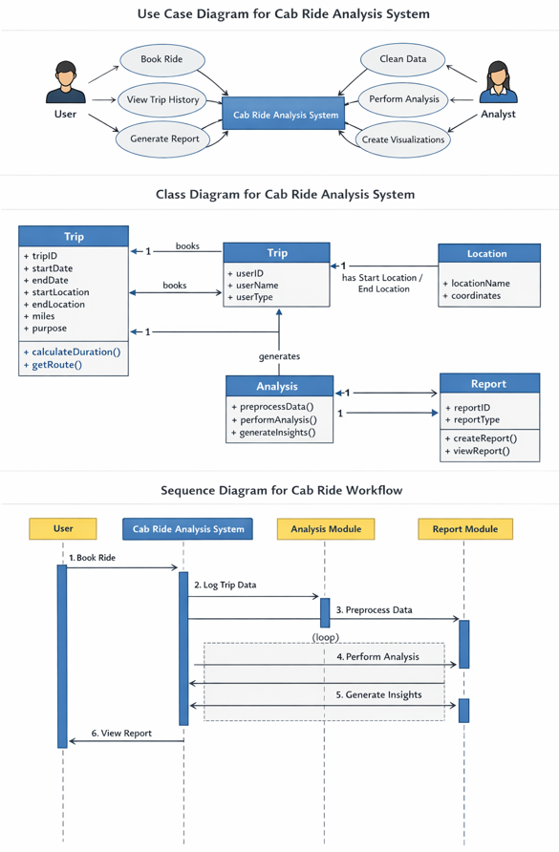
USE CASE DIAGRAM
The Use Case Diagram represents the interaction between external users (actors) and the cab travel analysis system. It provides a high-level view of how different users interact with the system and what functionalities are available.
Actors
- User
  - Represents a general user or stakeholder who interacts with the system
  - Interested in viewing results and reports
- Data Analyst
  - Responsible for processing data and performing analysis
  - Uses the system to generate insights and visualizations
Use Cases (Actions)
- Load Dataset
  - Upload or import cab travel data into the system
- Clean Data
  - Remove inconsistencies and handle missing values
- Perform Analysis
  - Analyze trip patterns, locations, and time-based trends
- Generate Visualizations
  - Create charts and graphs for better understanding
- Generate Report
  - Produce summarized insights from analysis
- View Results
  - Display outputs and findings to the user
System Interaction
- The Data Analyst interacts with the system to preprocess and analyze data
- The system processes the data and generates insights
- The User interacts with the system to view reports and visual outputs
- The system acts as a central unit connecting all actions and actors
This diagram helps in understanding the functional requirements and user interactions within the system.
CLASS DIAGRAM
The Class Diagram represents the internal structure of the system by defining classes, their attributes, methods, and relationships. It provides a blueprint of how data and functionalities are organized.
Main Classes
- Trip Class
  - Attributes:
    - start_date
    - end_date
    - category
    - start
    - stop
    - miles
    - purpose
  - Methods:
    - calculate_duration()
    - generate_route()
- ProcessedData Class
  - Attributes:
    - day
    - month
    - hour
    - route
    - trip_duration
    - is_weekend
    - high_distance
  - Methods:
    - transform_data()
    - classify_trip()
- Analysis Class
  - Attributes:
    - dataset
  - Methods:
    - analyze_time_patterns()
    - analyze_location_patterns()
    - analyze_routes()
    - analyze_purpose()
- Visualization Class
  - Methods:
    - plot_graphs()
    - generate_charts()
- Report Class
  - Attributes:
    - report_data
  - Methods:
    - create_summary()
    - display_results()
Relationships
- Trip data is passed to ProcessedData for transformation
- ProcessedData is used by Analysis for extracting insights
- Analysis results are passed to Visualization for graphical representation
- Visualization outputs are used by Report to generate final results
This diagram shows how different components of the system are connected and how data flows between them.

SEQUENCE DIAGRAM
The Sequence Diagram represents the step-by-step interaction between different components of the system over time. It shows how data flows from the user to the system and how results are generated.
Step-by-Step Interaction Flow
- User uploads dataset
  - The process begins when the user provides the cab travel dataset
- System loads data
  - The system reads and stores the dataset for processing
- Data preprocessing
  - Cleaning of data is performed
  - Missing values are handled
  - Data is formatted properly
- Feature engineering
  - New columns such as trip_duration, hour, and route are created
- Analysis execution
  - System performs:
    - Time-based analysis
    - Location-based analysis
    - Route analysis
    - Purpose analysis
- Visualization generation
  - Graphs and charts are created to represent patterns
- Insight generation
  - Key findings such as peak hours and high-demand routes are identified
- Report generation
  - Results are compiled into structured output
- User views results
  - Final outputs are displayed to the user through the interface
Interaction Summary
- The system acts as a central controller handling all processes
- Data flows sequentially from input to output
- Each module interacts with the next stage to complete the workflow
This diagram helps in understanding the dynamic behavior of the system and how different components interact during execution.

SUMMARY
- Use Case Diagram explains user interactions and system functionalities
- Class Diagram defines system structure and relationships
- Sequence Diagram shows step-by-step execution flow
Together, these UML diagrams provide a complete understanding of the system from functional, structural, and behavioral perspectives.
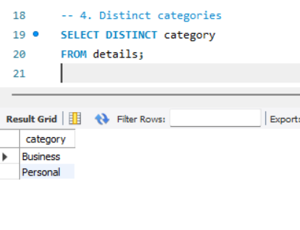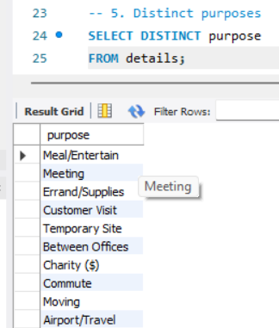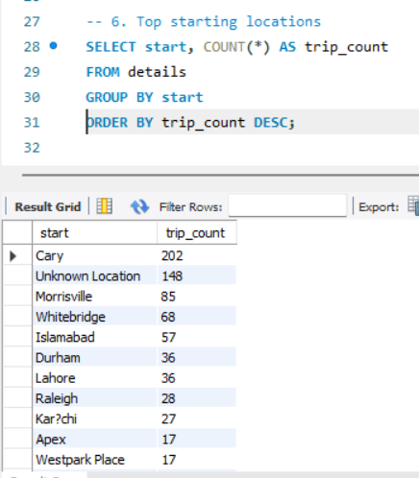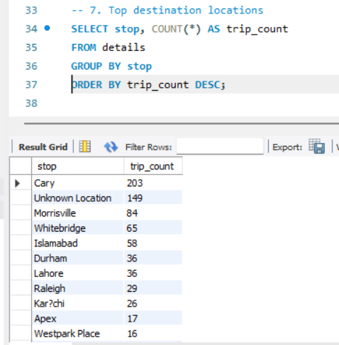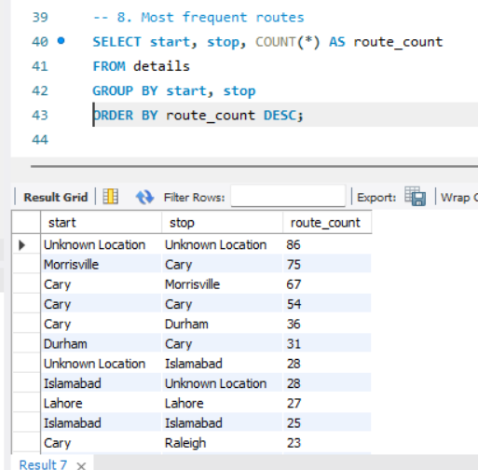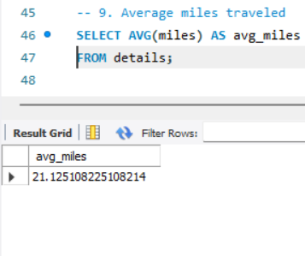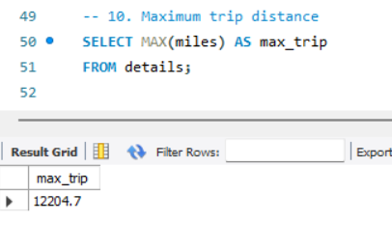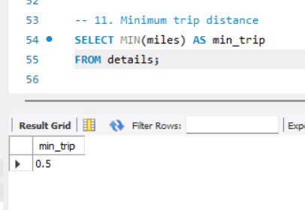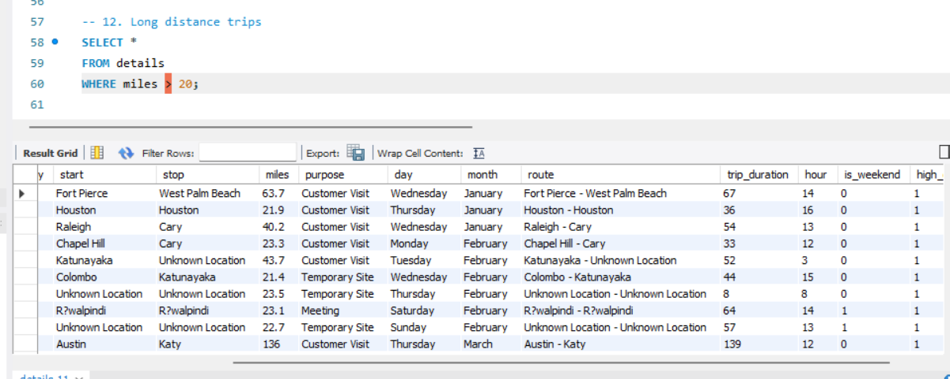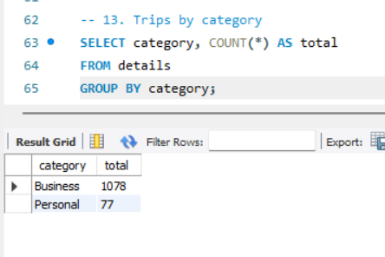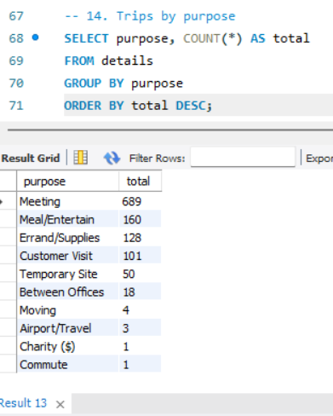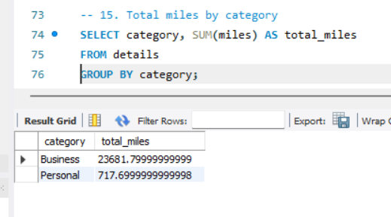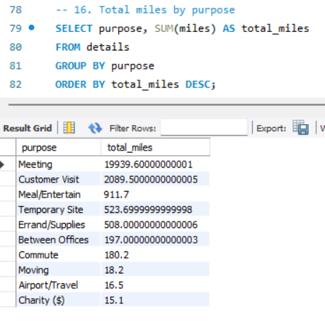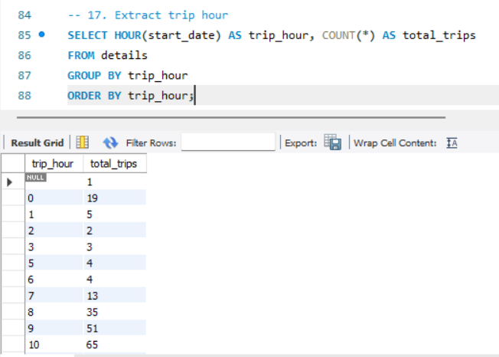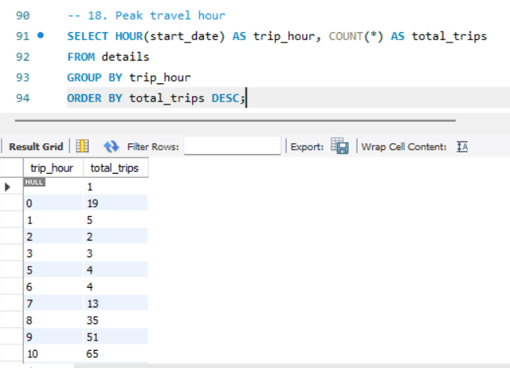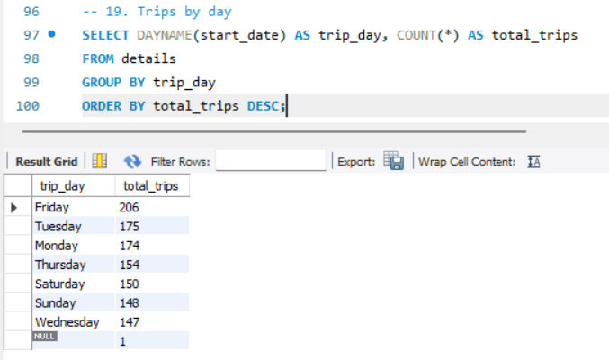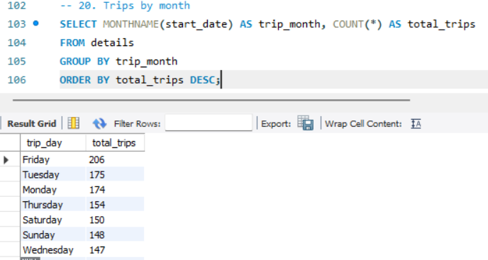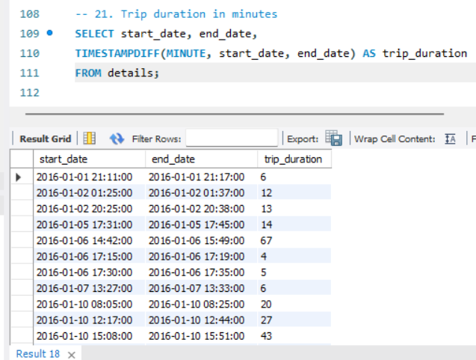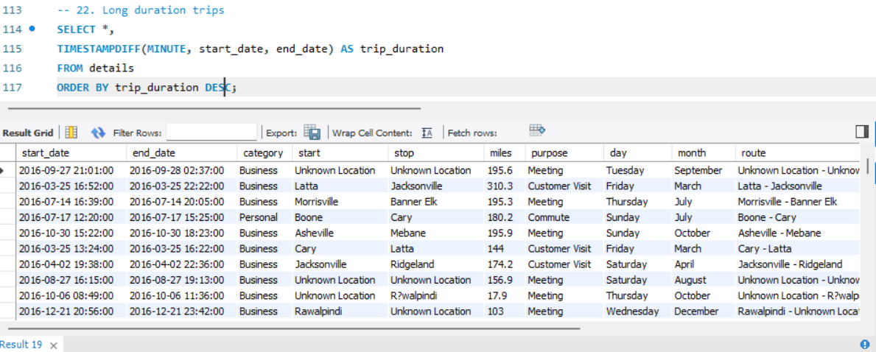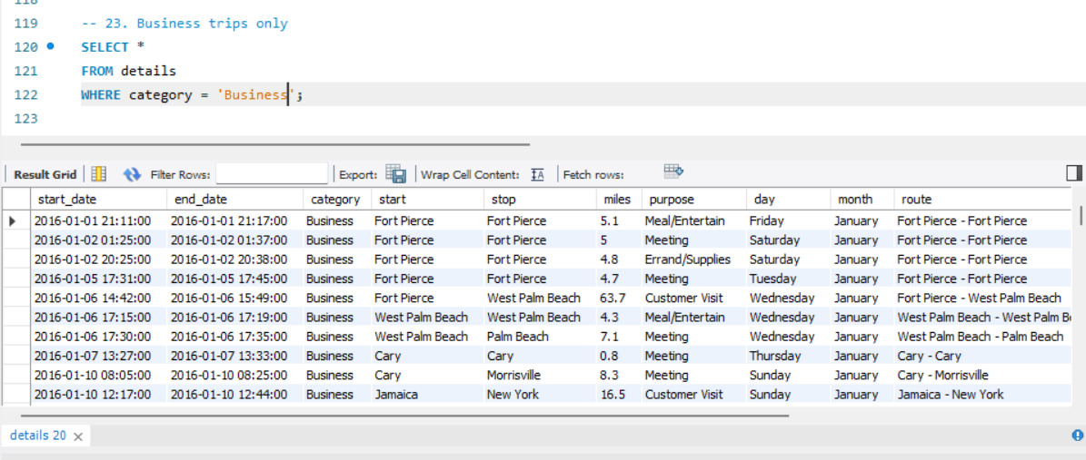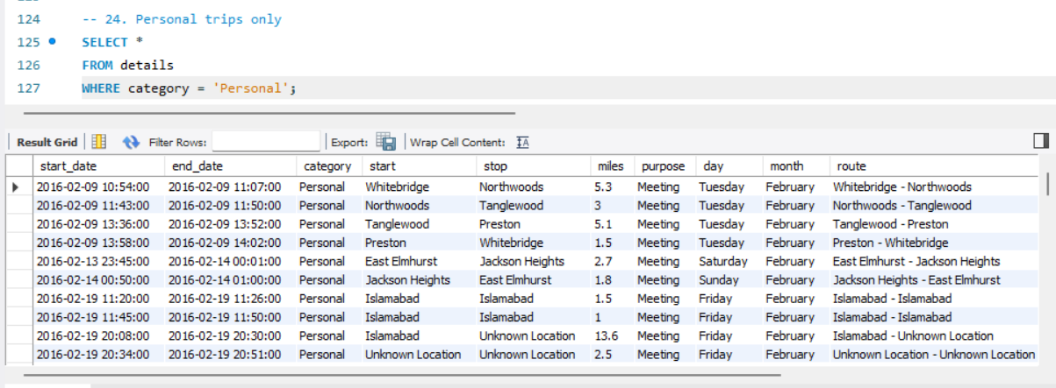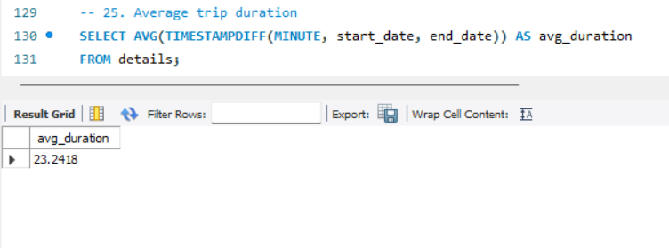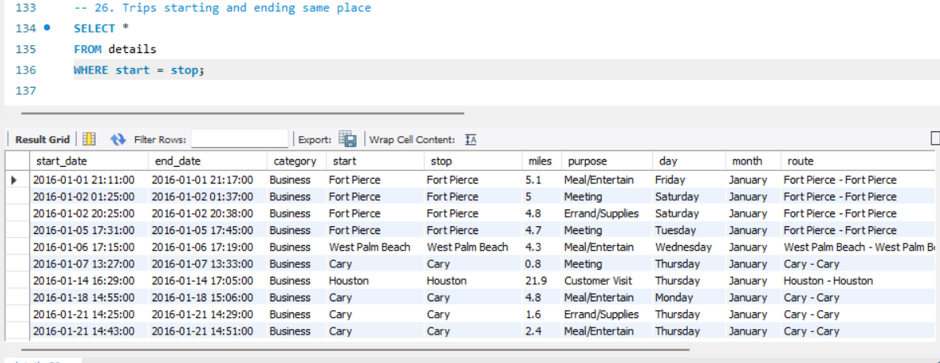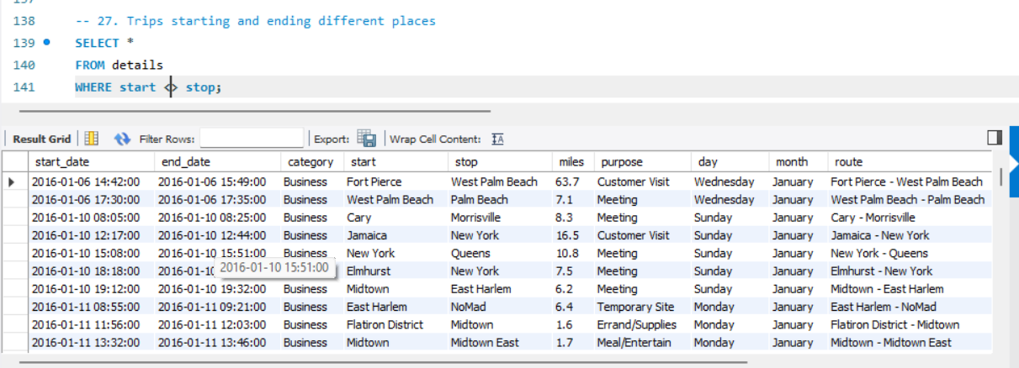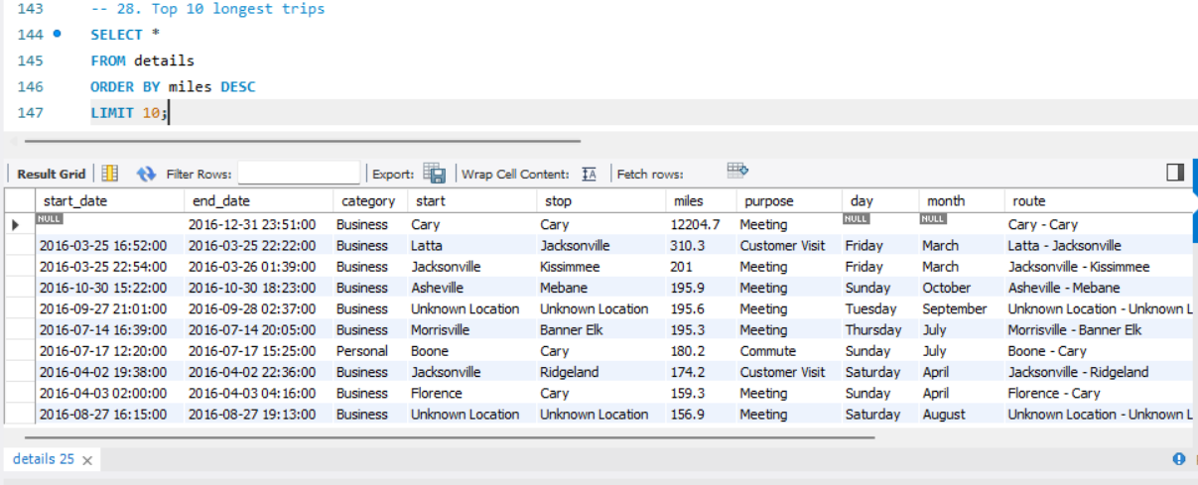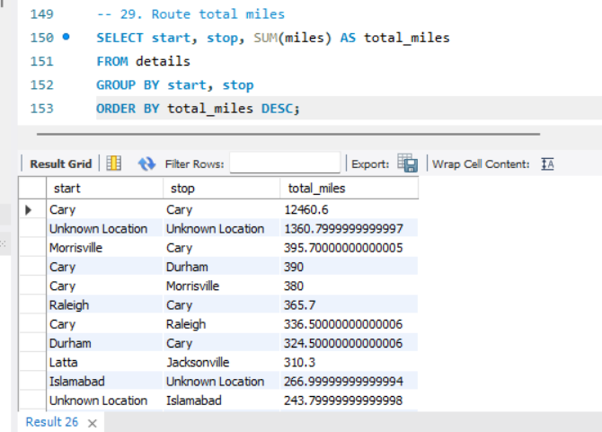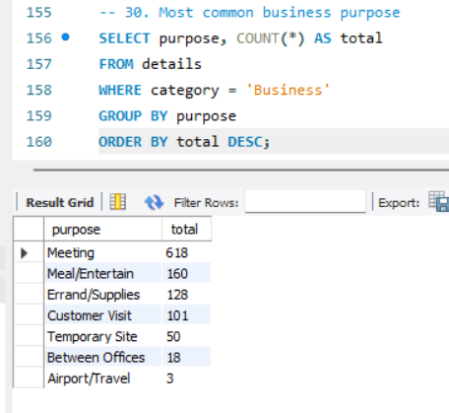
14. OUTPUT SCREENSHOTS + ANALYSIS
The output results generated from the cab travel dataset provide valuable insights into travel behavior, demand patterns, and operational trends. Each output highlights a specific aspect of the dataset, and together they form a comprehensive understanding of urban mobility.
The analysis of top start locations shows that Cary is the most frequently used pickup point, followed by locations such as Unknown Location, Morrisville, and Whitebridge. This indicates that Cary acts as a central hub for cab demand, likely due to high commercial or residential activity. The presence of "Unknown Location" suggests missing or incomplete data, which highlights the importance of proper data preprocessing. Overall, this pattern indicates that cab services should be concentrated in high-demand areas to improve availability and reduce waiting time.
The top stop locations output closely mirrors the start location distribution, with Cary again appearing as the most frequent destination. This reflects a strong movement of trips within and around key urban hubs. The similarity between start and stop patterns suggests a balanced flow of travel between major locations. It also indicates that certain areas function both as origins and destinations, emphasizing their importance in the transportation network.
The top routes analysis provides deeper insight into travel connectivity. Routes such as Morrisville to Cary and Cary to Morrisville appear frequently, indicating strong bidirectional movement between these locations. Additionally, routes where the start and stop locations are the same, such as Cary to Cary, highlight local travel within a single area. The repeated occurrence of specific routes suggests predictable travel behavior, which can be leveraged for route optimization and better cab allocation.
The category distribution output reveals that the majority of trips fall under the business category, with very few personal trips recorded. This indicates that cab services are primarily used for professional purposes such as meetings, office commutes, and client visits. This trend aligns with typical urban travel behavior and suggests that demand is closely linked to business activity and working hours.
The purpose analysis output shows that meetings account for the largest share of trips, followed by meal/entertainment and errands. This highlights that cab usage is heavily driven by professional and utility-based activities. The presence of categories like customer visits further reinforces the importance of cab services in business operations. Less frequent purposes such as airport travel indicate specialized use cases.
The average miles output indicates that the typical trip distance is around 21 miles. This suggests a mix of short and medium-distance travel, with occasional long-distance trips. The presence of long trips in the dataset indicates that cab services are not limited to short commutes but are also used for inter-city or extended travel.
The longest trips analysis reveals extreme values, including trips with very high mileage. While some of these may represent actual long-distance travel, others may indicate data anomalies or errors. This highlights the importance of data validation during preprocessing. However, the presence of long-distance trips also suggests that the system supports diverse travel needs.
The trips by hour analysis shows a clear trend in time-based demand. The number of trips increases during the day and peaks between afternoon and early evening hours, particularly around 3 PM to 6 PM. This pattern reflects typical working hours and business activities. Early morning and late-night hours show significantly lower activity, indicating reduced demand during these periods. This insight is crucial for optimizing cab availability based on time.
The trips by day analysis indicates that Friday has the highest number of trips, followed by other weekdays such as Tuesday and Monday. This suggests increased activity towards the end of the workweek, possibly due to meetings, deadlines, or social engagements. Weekend days also show considerable activity, reflecting personal and leisure travel. The relatively balanced distribution across days indicates consistent demand throughout the week.
Overall, the outputs collectively reveal that cab travel behavior is influenced by time, location, and purpose. High-demand locations, peak hours, and frequently used routes form the core of urban mobility patterns. These insights can be used to improve cab allocation, optimize routes, and enhance service efficiency. The analysis demonstrates the effectiveness of data analytics in transforming raw data into meaningful and actionable insights.
15. OVERALL CONCLUSION
The analysis of cab travel behavior in this project provides a comprehensive understanding of urban mobility patterns and highlights the importance of data-driven decision-making in transportation systems. By systematically processing and analyzing the dataset, meaningful insights have been derived regarding how cab services are utilized across different locations, time periods, and purposes.
One of the key findings of this project is the identification of high-demand locations such as Cary and Morrisville, which act as major hubs for both pickup and drop-off activities. This indicates that certain areas consistently generate higher travel demand and require better cab availability. Similarly, the analysis of routes reveals that specific travel paths, such as between Cary and Morrisville, are frequently used, indicating strong connectivity and predictable movement patterns within the city.
Time-based analysis further highlights important trends in travel behavior. The identification of peak travel hours, particularly during the afternoon and early evening, reflects typical working schedules and business activities. The observation that Fridays have the highest number of trips suggests increased travel activity towards the end of the workweek. These findings emphasize the need for dynamic resource allocation based on time and demand.
Another important insight from the analysis is the dominance of business-related travel, with the majority of trips categorized under business purposes such as meetings and customer visits. This indicates that cab services play a significant role in professional activities and corporate mobility. At the same time, the presence of personal and leisure trips during weekends highlights the versatility of cab services in supporting different types of travel needs.
Distance analysis shows that most trips are short to medium in length, with occasional long-distance journeys. This suggests that cab services are widely used for both local and extended travel. However, the presence of extreme values in the dataset also highlights the importance of data preprocessing and validation to ensure accuracy and reliability.
The benefits of this project are evident in its ability to transform raw data into actionable insights. By identifying demand patterns, high-traffic routes, and user behavior, the system can support better decision-making in cab service operations. These insights can be used to optimize cab allocation, reduce waiting times, improve route planning, and enhance overall service efficiency. Additionally, the use of visualization tools helps in presenting complex data in an easily understandable format, making it accessible to both technical and non-technical users.
From a learning perspective, this project provides valuable experience in applying data analytics techniques to real-world problems. It demonstrates the importance of data preprocessing, feature engineering, and exploratory analysis in extracting meaningful information from datasets. The use of tools such as Python, Pandas, NumPy, Matplotlib, SQL, and Power BI highlights the integration of multiple technologies in a single workflow. This project also enhances skills in data interpretation, problem-solving, and analytical thinking.
Furthermore, the project illustrates how data analytics can be used to address real-world challenges in urban mobility. By understanding travel patterns and user behavior, transportation systems can be made more efficient, reliable, and user-friendly. The insights generated in this study can be extended to larger datasets and more complex systems, providing a foundation for future research and development.
In conclusion, the project successfully achieves its objective of analyzing cab travel behavior and extracting meaningful insights. It demonstrates the power of data analytics in improving transportation systems and highlights the potential for further advancements in this field. The combination of structured methodology, effective tools, and detailed analysis ensures that the project delivers both academic value and practical relevance.

